**Experiment 2**

**Student Name:**Rajiv Paul **UID:**20BCS1812

**Branch:** CSE **Section/Group:** 702 A

**Semester:** 5th **Date of Performance:** 11/8/2022

**Subject Name:** DAA Lab **Subject Code:** 20-CSP-312

**1. Aim/Overview of the practical:**

Code implement power function in O(logn) time complexity.

**2. Task to be done/ Which logistics used:**

To find power of a numbers.

**3. Algorithm/Flowchart (For programming based labs):**

**4. Steps for experiment/practical/Code:**

*package com.DAA*;

*public class DAA_exp1_2* {

*public static void* main(*String*[] *args*) {

*int* x = 2;

*int* y = 7;

*System*.out.println("The output after performing power function: "+*power*(x,y));

}

*static int* power(*int a*,*int b*){

*if*(*b*==0){

*return* 1;

}

*else if*(*b* % 2 ==0 ){

*return power*(*a*,*b*/2) * *power*(*a*,*b*/2);

}

*else*

*return a* * *power*(*a*,*b*/2) * *power*(*a*,*b*/2);

}

}

**5. Observations/Discussions/ Complexity Analysis:**

Time complexity of finding power of a number using recursion is O(log n).

**6. Result/Output/Writing Summary:**

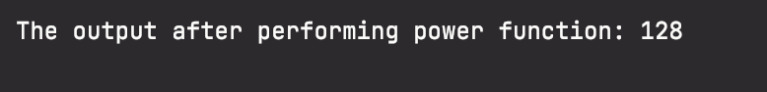

**Learning outcomes (What I have learnt):**

**1. Learnt how to calculate power of a function.**

**2. Learnt how to use recursion for solving problem.**

**3.**

**4.**

**5.**

**Evaluation Grid (To be created as per the SOP and Assessment guidelines by the faculty):**

|  |  |  |  |
| --- | --- | --- | --- |
| Sr. No. | Parameters | Marks Obtained | Maximum Marks |
| 1. |  |  |  |
| 2. |  |  |  |
| 3. |  |  |  |
|  |  |  |  |